

**Kallam Haranadhareddy Institute of Technology**

**Pizza Delivery App Using Salesforce**

**By**

**N.Uzwala Priya**

[**218x1a4421@khitguntur.ac.in**](mailto:218x1a4421@khitguntur.ac.in)

**Sk.RiyazMohiddin**

[**228x5a4405@khitguntur.ac.in**](mailto:228x5a4405@khitguntur.ac.in)

**Sk.Basheer Babu**

[**218x1a4430@khitguntur.ac.in**](mailto:218x1a4430@khitguntur.ac.in)

**V.Maniratnam**

[**218x1a4460@khitguntur.ac.in**](mailto:218x1a4460@khitguntur.ac.in)

**Project Abstract**

This **Pizza Delivery Application**, built using **Salesforce Lightning**, makes ordering and delivering pizzas faster and smarter. Customers can easily place orders, customize their pizzas, make secure payments, and track deliveries in real time. The app uses **Salesforce Maps** to help delivery agents find the best routes, ensuring quick and efficient service.

With features like **automated order management, push notifications, and real-time tracking**, the application enhances both customer convenience and business efficiency. A **custom Salesforce dashboard** provides insights into orders, deliveries, and customer preferences, helping businesses improve service quality.

### **Introduction**

### In today's fast-paced world, customers expect quick and efficient food delivery services. This **Pizza Delivery Application**, built using **Salesforce Lightning**, aims to simplify and automate the pizza ordering and delivery process. The application provides a seamless experience for customers to place orders, track deliveries in real time, and make secure payments. By leveraging **Salesforce’s cloud-based platform**, businesses can efficiently manage orders, assign delivery agents, and optimize routes to ensure timely deliveries. The use of **Lightning Components, Apex, and Salesforce automation tools** enhances performance, scalability, and user experience.

### **Objectives**

### **Customer Convenience –** Provide an easy-to-use interface for ordering and tracking pizza deliveries.

### **Real-Time Order Tracking –** Enable customers and delivery agents to track orders using Salesforce Maps.

### **Automated Order Management –** Use Apex triggers and workflows to assign orders to the nearest available delivery agent.

### **Optimized Delivery Routes –** Implement AI-powered route optimization for faster deliveries.

### **Step-by-Step Implementation**

#### **1. Introduction & Creation of Salesforce Org**

* **Sign up for Salesforce Developer Edition** at [**Salesforce Developer**](https://developer.salesforce.com/signup).
* **Login to Salesforce** and navigate to **Setup**.
* **Create a New Org** for the **Pizza Delivery**.
* Define the **Org Name, Domain, and Admin Credentials**.
* 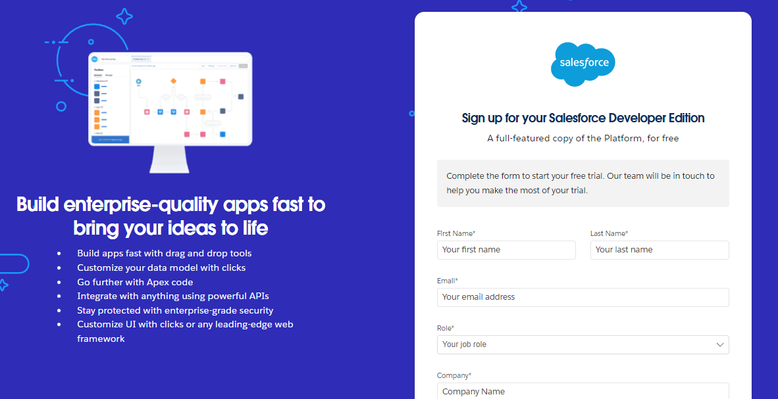Configure basic settings like **Locale, Language, and Time Zone**

**2. Object creation**

* Objects are The most Basic Parameters Used to create any thing in the salesforce
* 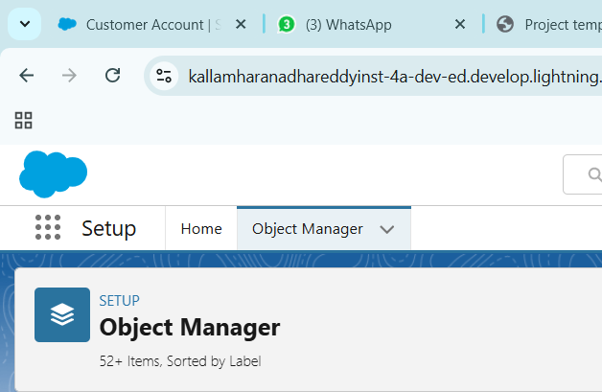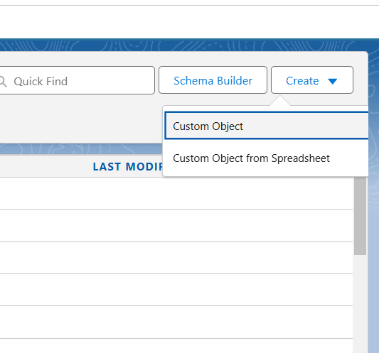So for the Pizza Delivery Application we need Some Objects **called Customer Detail, Everyday value, Best Seller , new Launches, Pizza(Record Type), Beveragers, Mode of Payment.**

Let’s Create an Object Called **Customer Detail**

* 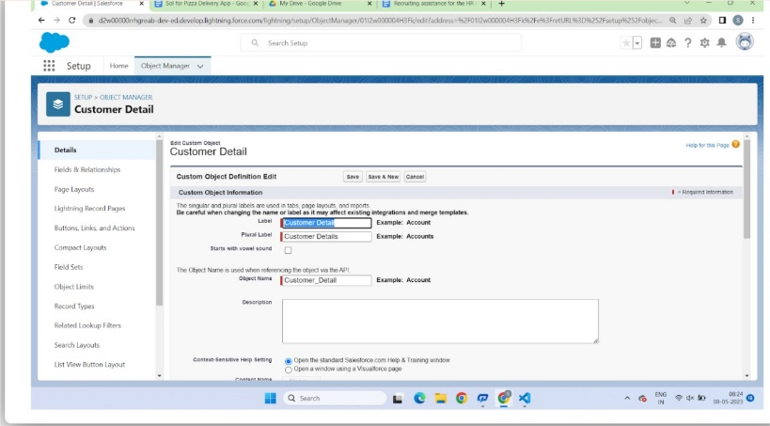In the Process We need to fill In the fields And Create the Custom Object
* In the same way we created all The custom Objects Needed.

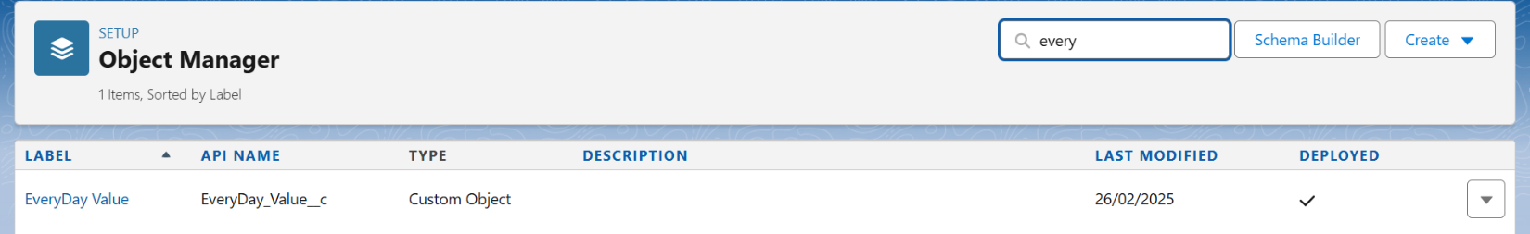

**Tabs**

* 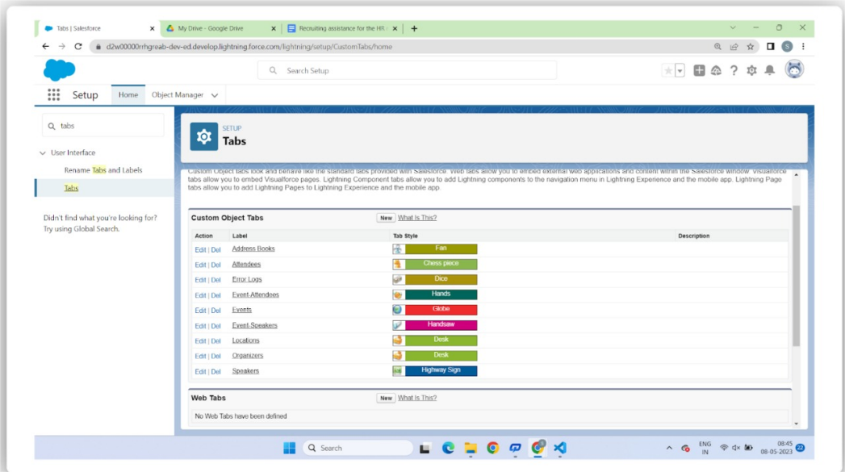We created the Objects in the previous step so we need to create the tabs for the Created custom objects.

**Creating the Lightning App**

* We need to A Lightning App Called **“Pizza Delivery”.**
* App Creation Is one of the crucial Steps in the Pizza Delivery Project so we need to Crete the app by including all the custom objects created int the previous steps**.**

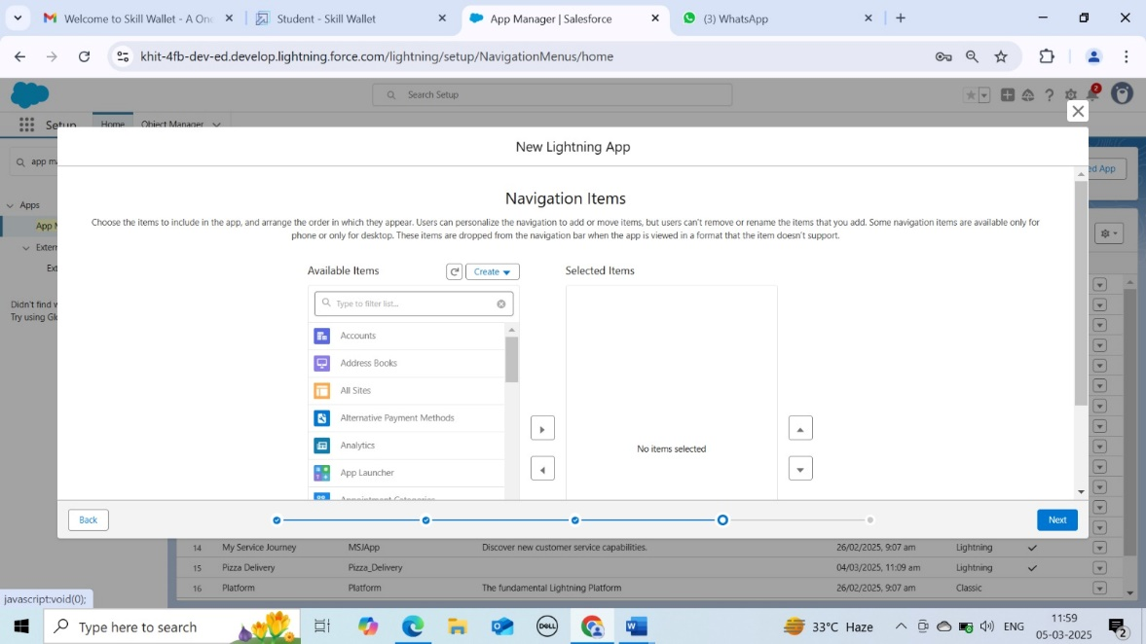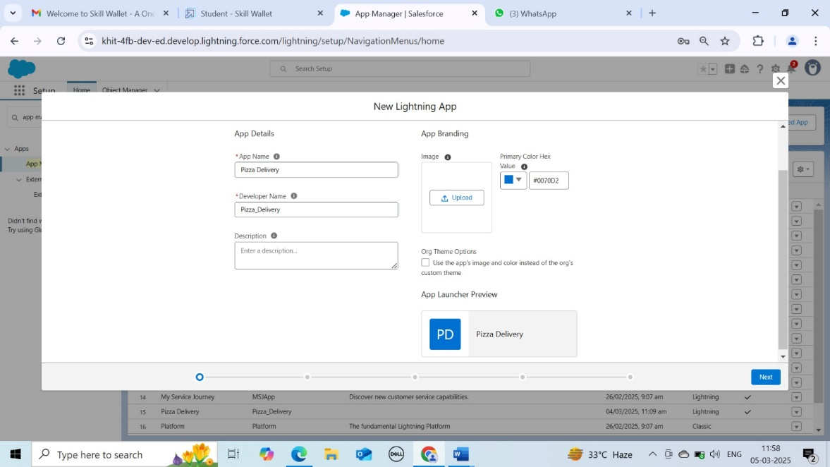

**Fields and Relationships**

* After app Creation we need to create the fields and Relationships in the Custom Objects
* A screenshot of a computer

  AI-generated content may be incorrect.The Fields We created are **Delivery field in Everyday Value**
* **Crust Field in Best Seller Object**
* **Beverages Fiels in New Launches Object**
* 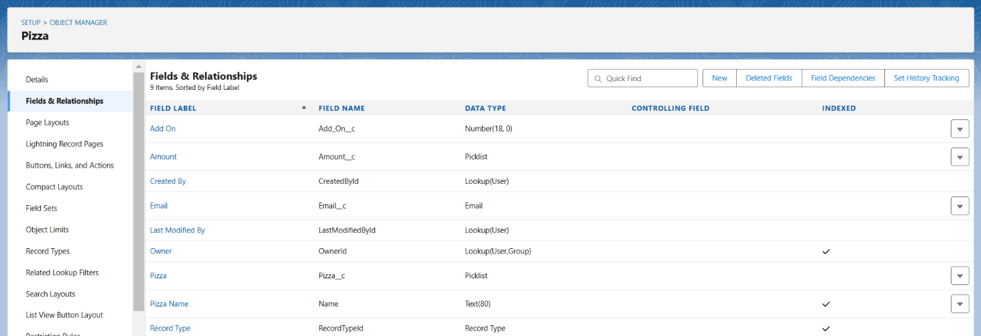**Types of Pizzas, Amount and add on Fields in Pizza Object**
* **Types of Cold Drinks in Beverages Object**
* A screenshot of a computer

  AI-generated content may be incorrect.**Typed of Roasted Chicken in Customer detail Object**
* **Mode of Payment field in Mode of payment Object.**

**Record Types**

* Salesforce Record Types are a way of Grouping many records of one type for that Object.
* We are creating the Records for the Object **Pizza** in this Case.

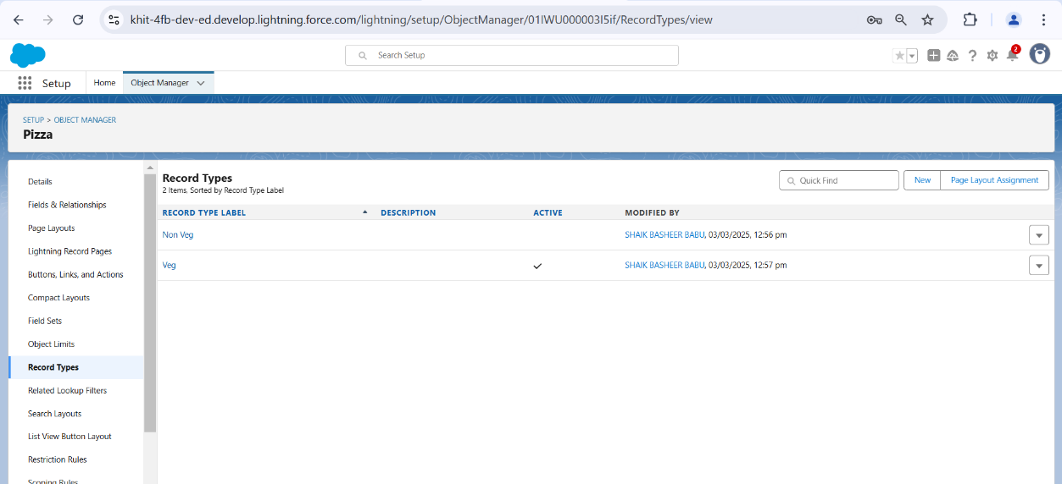

* 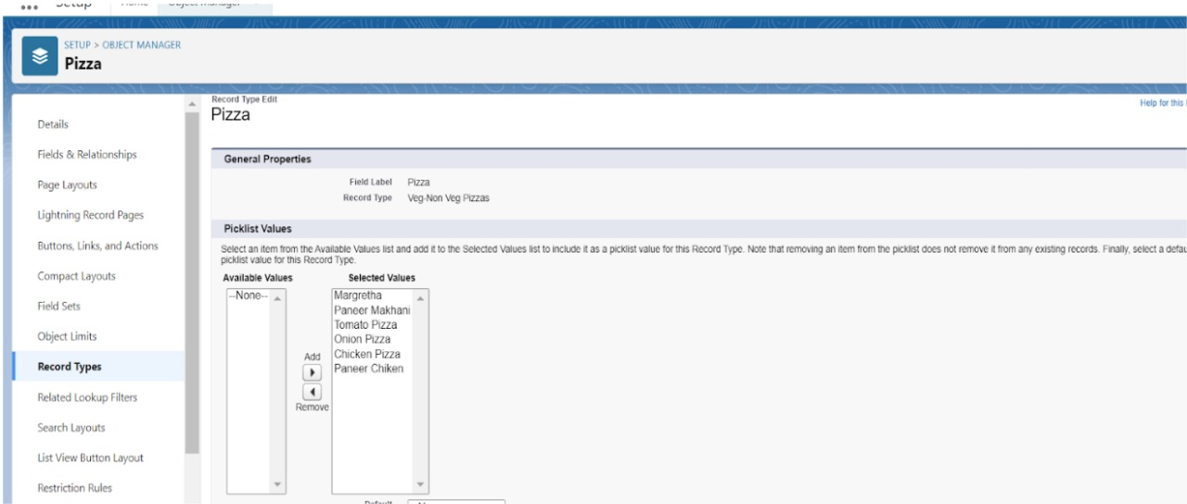In the Pizza Object we Created the Records **Veg** and **Non veg** To categeorize the types of Pizzas That are Being Ordered.
* In the Veg and Non Veg Records **we categeorized the Pizzas into the groups Veg and Non veg** and saved them**.**

**Profiles**

* We are supposed to create custom Profiles in this step.
* To create new profile we cloned an Existing profileof **Standard platform user.**
* We named the new custom profile as **Sales Manager.**

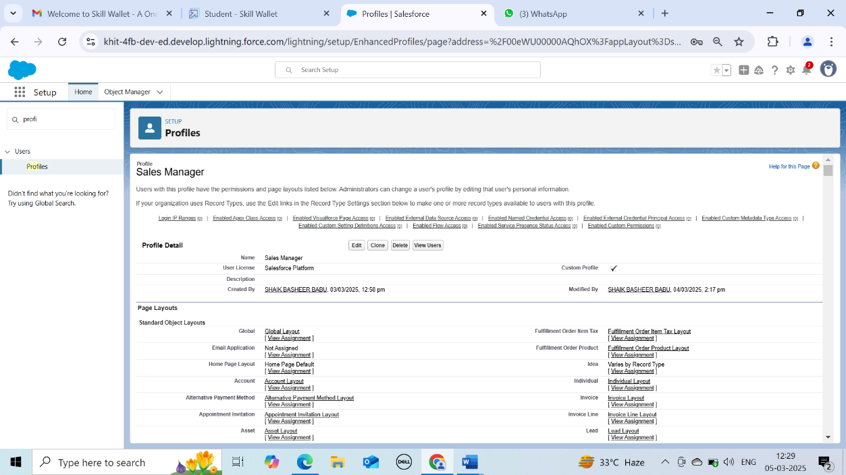

* 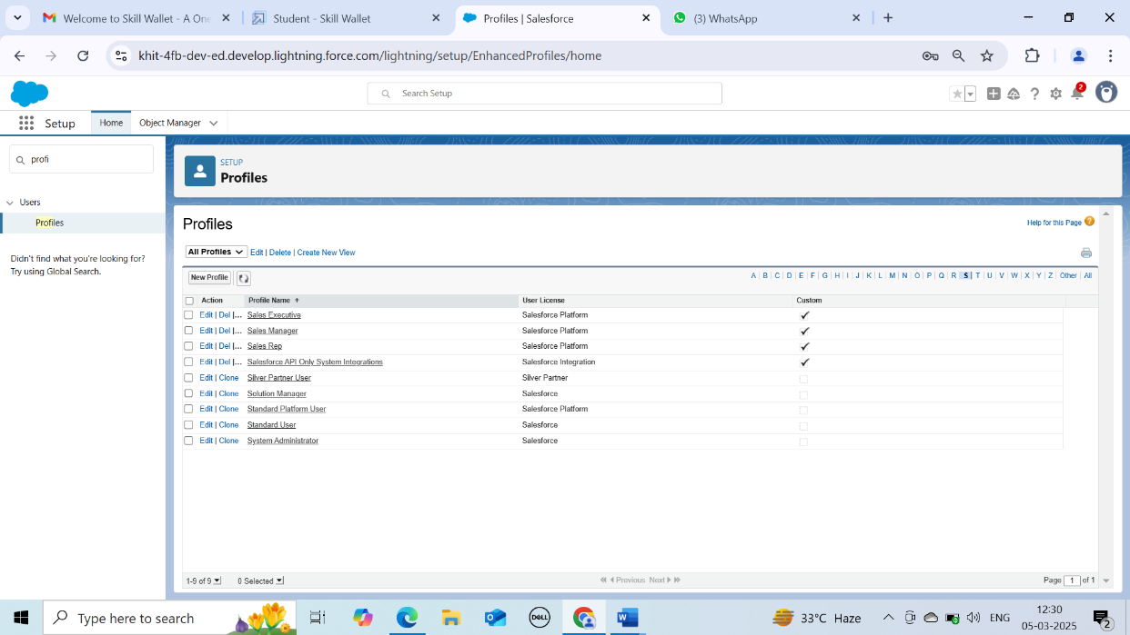In the same way we created a few custom profiles called **Sales Rep,Sales executive** and **Delivery person.**

**User Adoption**

* Every user in salesforce has a user Account. The user Account identifies the user, and The user account settings determine what features and records the user can access.
* We need to create User Interfaces for the profiles that we created in the previous step.

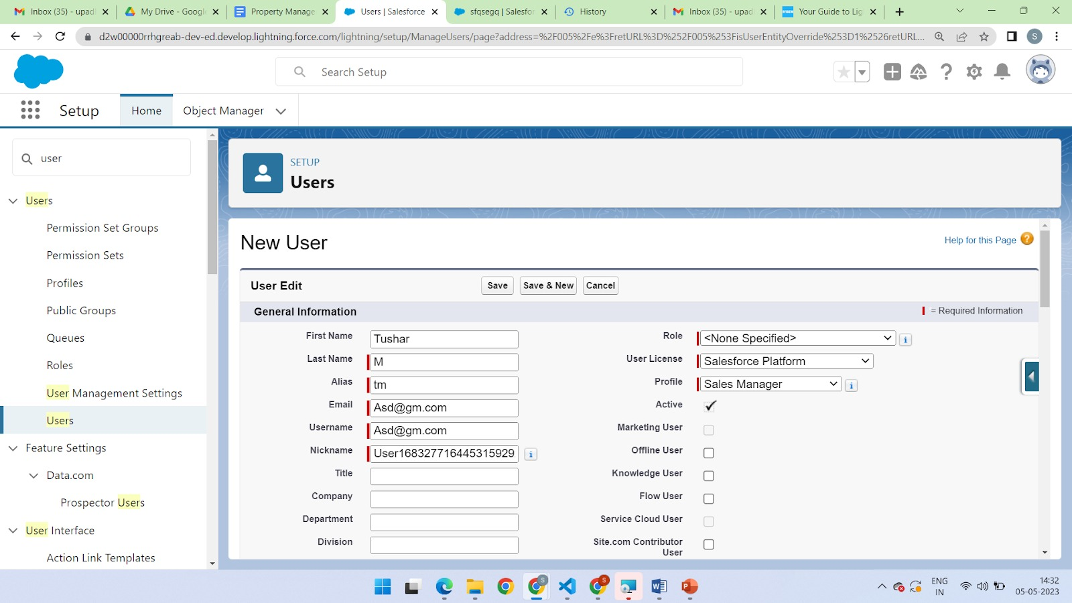

* We created the Profiles **Sales Manager**, **Sales Rep** and **Delivery Driver** in the step earlier so we need to create users and and assign them to their Respective profiles.

**Organization wide Default(OWD)**

* Rorganization wide Defaults are the pattern security rules that you can follow for your Salesforce Instance.
* These are utilized to Confine who can access what information in your CRM.
* Primary levels of access we can set are :

1. Public Read/Write/Transfer
2. Public Read/Write
3. Public Read/only
4. Private

* For each Object, Select the default access you want to give everyone.
* For every Custom object give private as a record level security.

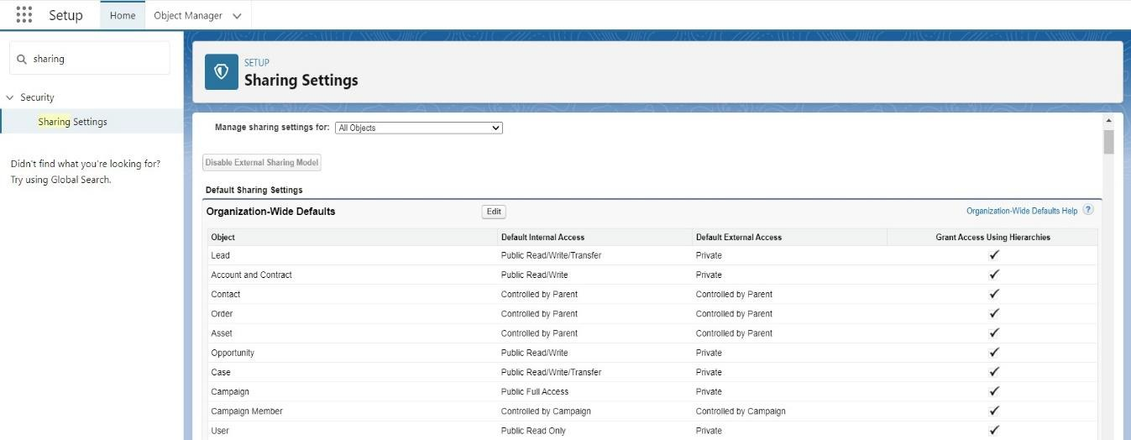

**Reports**

* Reports give you access to your salesforce data you can examine your salesforce data in almost infinite combinations,display it in easy to understand formats, Aand share the resulting insights with others.
* Types of records in Salesforce
  + **Tabular**
  + **Summary**
  + **Matrix**
  + **Joined Reports**
* 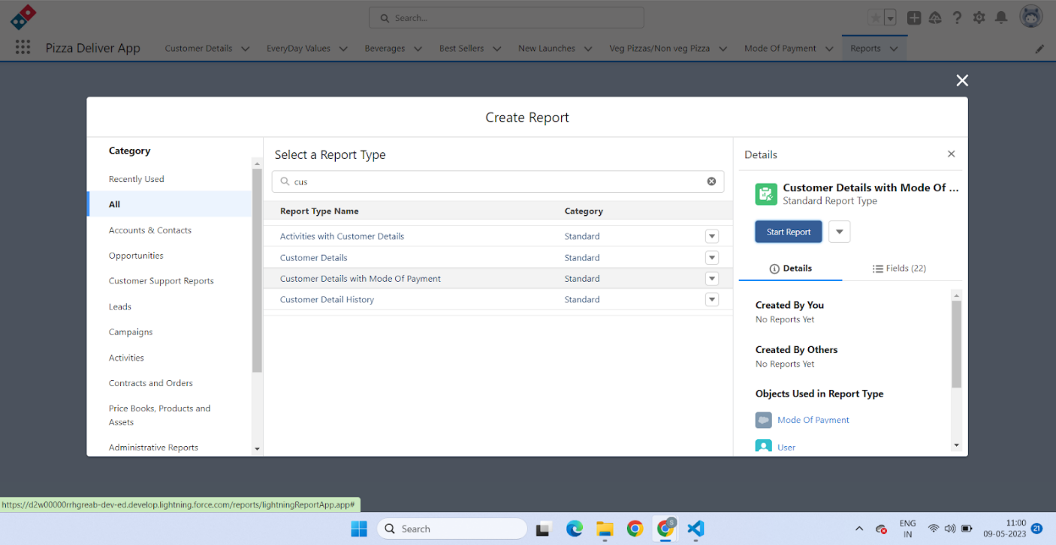Creating the report:
* A screenshot of a computer

  AI-generated content may be incorrect.**We Created the Report called customer details with mode of payment**

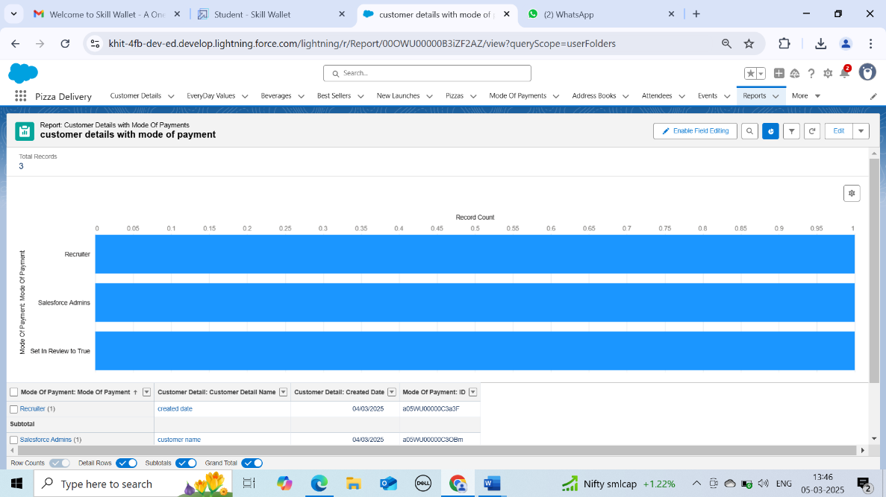

**Apex Triggers**

* **Apex Triggers** enable you to perform custom actions.
* **A trigger** is Apex code that executes before and after the following actions.
  + **Insert**
  + **Update**
  + **Delete**
  + **Merge**
  + **Upsert**
  + 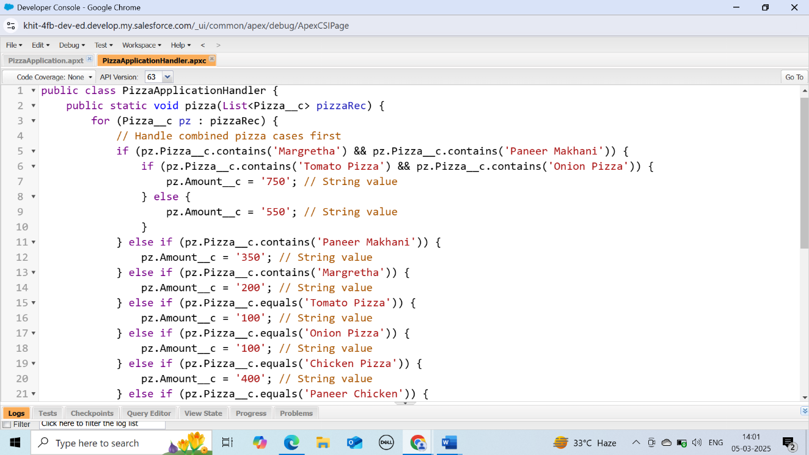**Undelete**
* We Created A trigger called **Pizza Application** for the scenario like whenever the customer is selecting the pizza whether it is Veg Pizza or Non veg pizza according to the selection of pizza the **Amount** field.
* 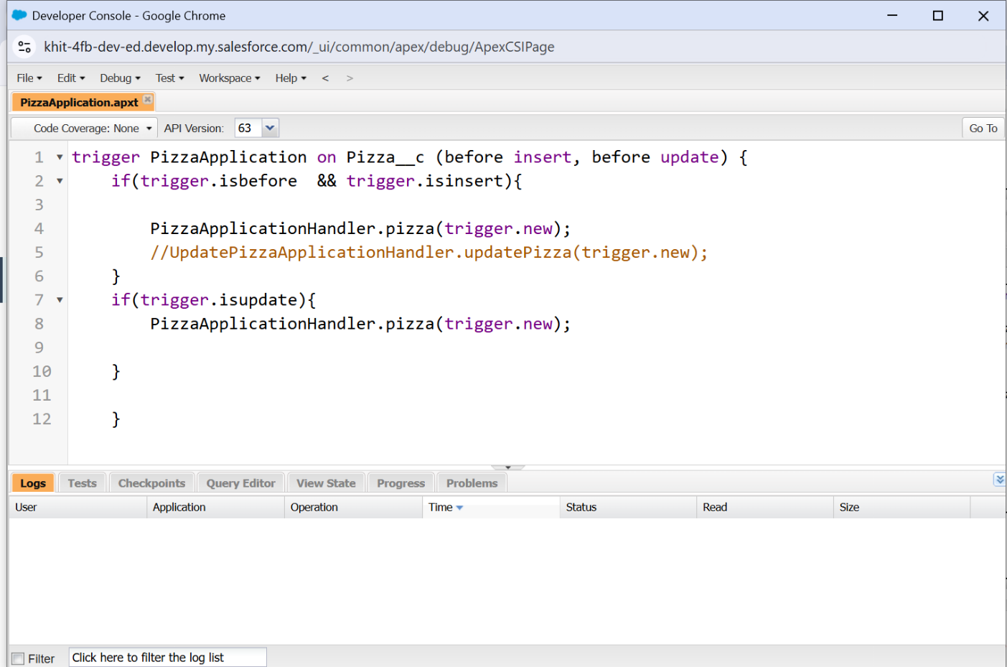Next is **Pizza Application Handler** class

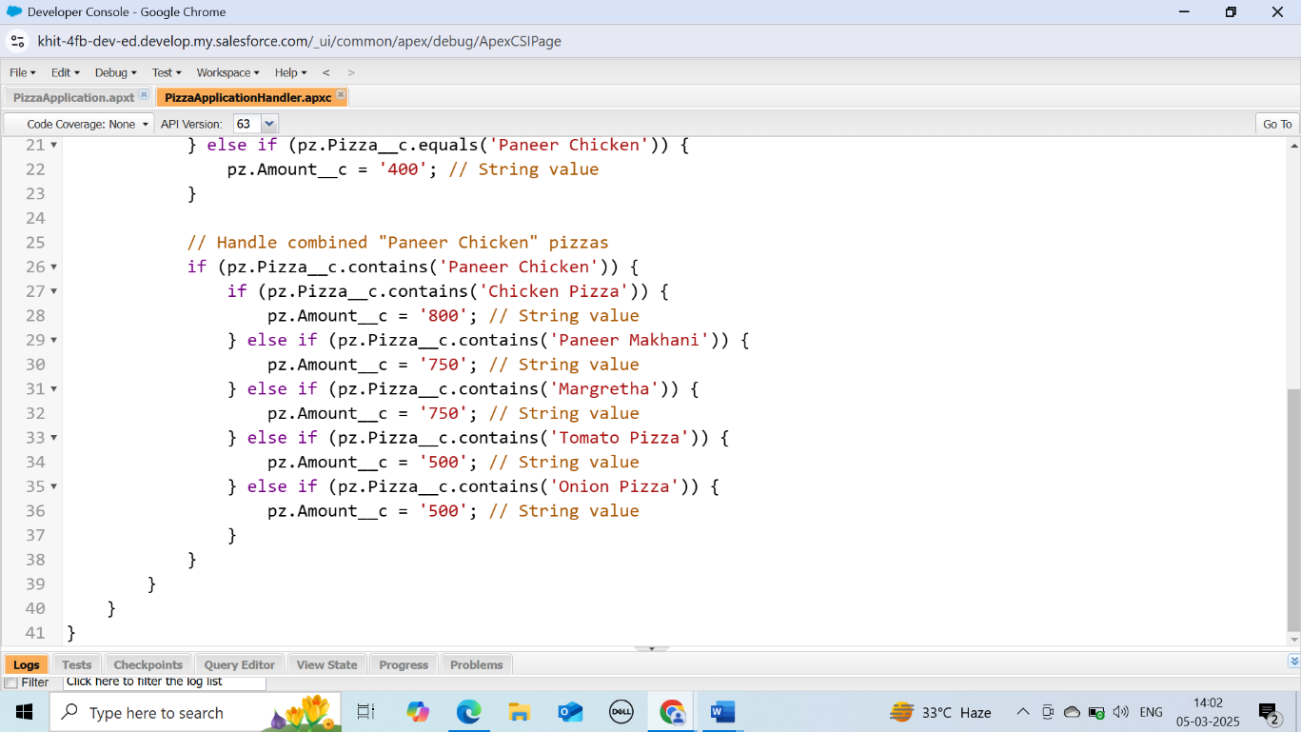**Schedule Apex**

* It is the feature that allows you to schedule the excecution of the Apex classes to run at specific times.
* To schedule the Excecution of the class you can use the salesforce Developer console or the salesforce user interface.
* We created **Schedule apex for frequently visited Customers.**
* That Scheduler is called **Pizza discount scheduler.**

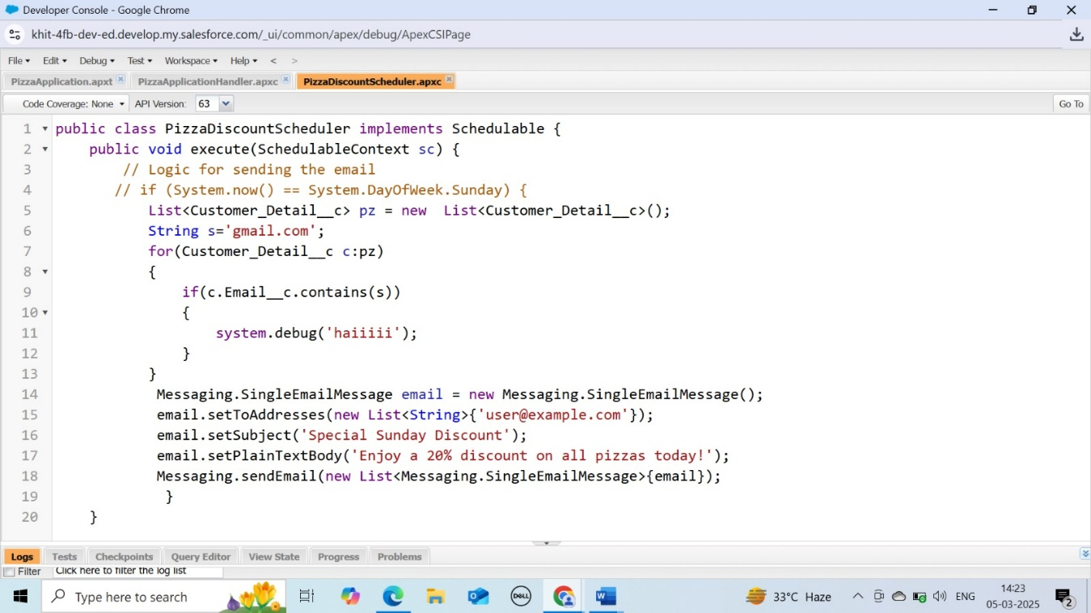

* 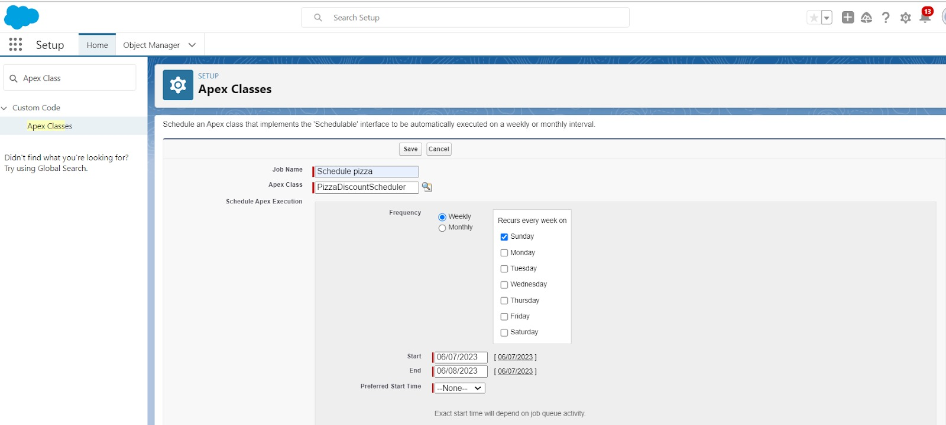**Now another Schedule to send the mail to the Customer.**

**This concludes the project.**

**Future Approaches**

to enhance the Pizza Delivery App, future updates can include:

* AI-Powered Predictive Analytics
* Forecast customer demand using AI and machine learning.
* Suggest popular pizzas based on customer history.
* Voice & Chatbot Integration

**Conclusion**

The implementation of a Pizza Delivery App using Salesforce successfully leverages the capabilities of Salesforce Lightning Components, Apex, and automation tools to provide a seamless, efficient, and user-friendly experience